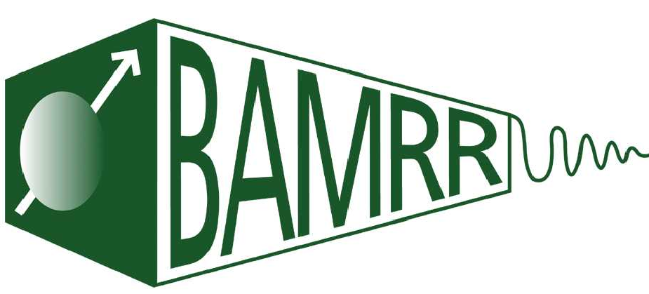

**The British Association of MR Radiographers**

**Introduction to MRI Course**

Supported by Guerbet

**Friday 4th November 2022**

|  |  |
| --- | --- |
| **Time** | **Day One** |
| **9:30** | **Registration and refreshments** |
| **10:00** | **Introductions**  Helen Estall - BAMRR  Consultant Radiographer, University Hospitals Leicester |
| **10:10** | **MRI Contrast Agents**  Trudi Whitehead - BAMRR  Lead MRI Safety Radiographer, University Hospitals Derby and Burton |
| **10:45** | **MRI Physics - How MRI works**  Dr Geoff Charles Edwards, Guy’s and St Thomas NHS FT Trust, London |
| **12:00** | **Lunch Break** |
| **13:00** | **MRI Physics - Pulse Sequences**  Dr Geoff Charles Edwards, Guy’s and St Thomas NHS FT Trust, London |
| **14:00** | **MRI Safety**  Trudi Whitehead - BAMRR  Lead MRI Safety Radiographer, University Hospitals Derby and Burton |
| **15:00** | **Coffee Break** |
| **15:30** | **MRI Artefacts**  Dr Paul Morgan, Head of Non-Ionising Physics  Nottingham University Hospital NHS Trust |
| **16:30** | **Close** |

**The British Association of MR Radiographers**

**Intro MRI Course**

Supported by Guerbet

**Saturday 5th November 2022**

|  |  |
| --- | --- |
| **Time** | **Day Two** |
| **9:00** | **Registration (no refreshments)** |
| **9:30** | **MRI MSK Imaging**  David Reed – BAMRR |
| **10:30** | **Coffee Break** |
| **11:00** | **MRI Neuro Imaging**  Helen Estall - BAMRR  Consultant Radiographer, University Hospitals Leicester |
| **12:00** | **Fat Free Imaging** |
| **12:30** | **Lunch Break** |
| **13:30** | ***Workshops (45min per session)***  **Group A** **Hands On Scanner**  Jonathan Coupland    **Group B** **MRI Knee**  David Reed  **Group C MRI L-Spine**  Helen Estall |
| **15:45** | **Course Review- Feedback** |
| **16:00** | **Close** |