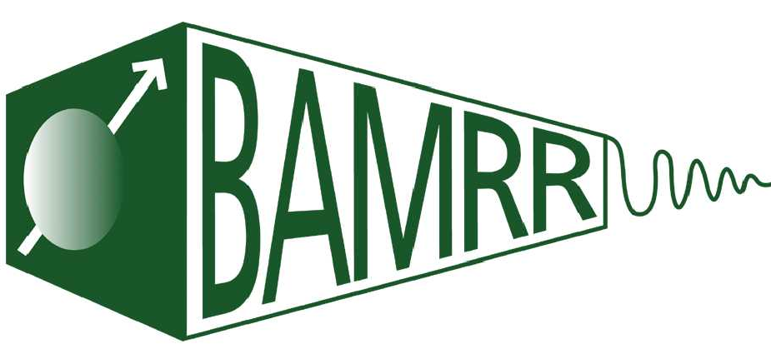

The British Association of MR Radiographers

Annual BAMRR Conference
Saturday 7th October 2023

09:15 | Registration and refreshments
09:30 | Welcome and Introductions
09:40 | We need to talk about Devices  Selene Rowe, Lead Radiographer for Intra-operative MRI, Nottingham University Hospitals NHS Trust
10:20 | Cardiac Pathology  Rebecca Mills, Lead Radiographer, Oxford Centre for Clinical MR Research
10:50 | Coffee break
11:10 | Incidental Bone Lesions ‘The good, the bad & the ugly’  Dr Aamer Iqbal, Consultant MSK Radiologist, Morriston Hospital Swansea
11:50 | On the Edge: Incidental Head and Neck Findings Not to Miss  Dr Ayesha Khatib FRCR, Cardiff and Vale NHS Trust
12:15 | MR Imaging of Petrous Apex Lesions  Dr James Johnston FRCR, Cardiff and Vale NHS Trust
12:40 | MR Imaging in Head and Neck Cancer  Dr Mary Hart FRCR, Cardiff and Vale NHS Trust
13:10 | AGM - BAMRR Members Only
13:15 – 14:00 | Lunch Break
14:00 | MR Proctography  Dr Adam Aboalkaz Consultant GI Radiologist, Cardiff and Vale NHS Trust
14:30 | Proctography in Practice  Stephanie Hughes Lead MR Radiographer Spire Cardiff Hospital
14:45 | Educational Grant: ‘the use of ‘fast’ MRI head scan to improve patient  experience and waiting time for investigation of headaches’  Laura Walker, Radiographer, RHCYP Edinburgh
15:00 | Coffee Break
15:15 | MR Imaging in Osteomyelitis  Dr Maria Constancia Ormasa, FRCR  MSK Consultant Radiologist, Cwm Taf Morgannwg Morgannwg Health Board
15:45 | The ‘MRI Pub Quiz’  Prof Martin Graves University of Cambridge
16:30 | Thanks and Close

